**Task 1**

1. Install the Jenkins in tomcat

Step 1: Download the **Jenkins WAR file**:

wget<http://mirrors.jenkins.io/war/latest/jenkins.war>

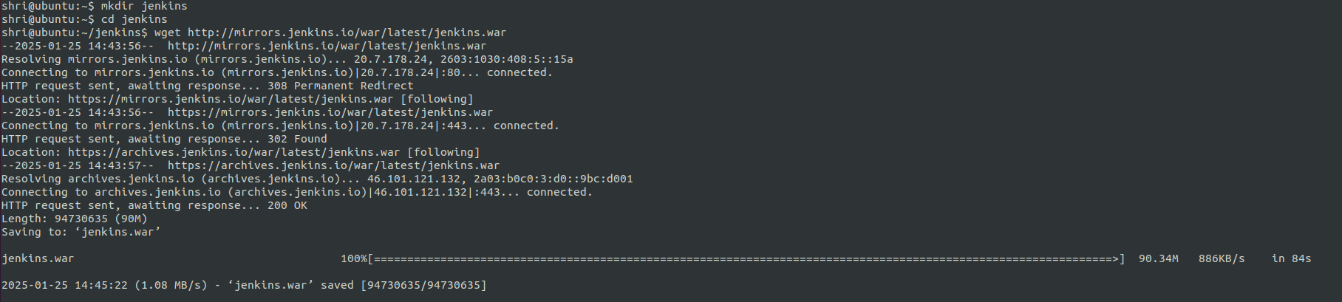

Step 2: copy/move Jenkins.war file to tomcats/webapps

mv ./Jenkins/Jenkins.war ./tomcats/apache-tomcat-9.0.98/webapps



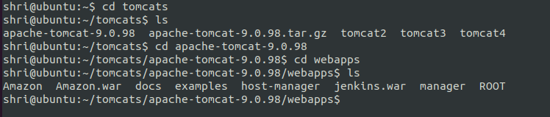

Step 3: restart tomcat by navigating to bin directory

Cd /tomcats/apache-tomcat-9.0.98/bin

Restart tomcat : ./shutdown.sh && ./startup.sh

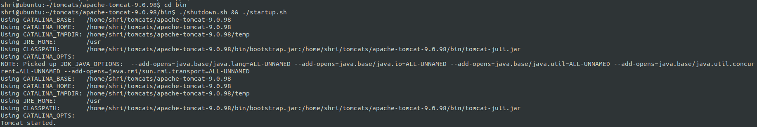

Step 4 :check if jenkinks is running, Open a web browser and go to:

<http://localhost:8080/jenkins>

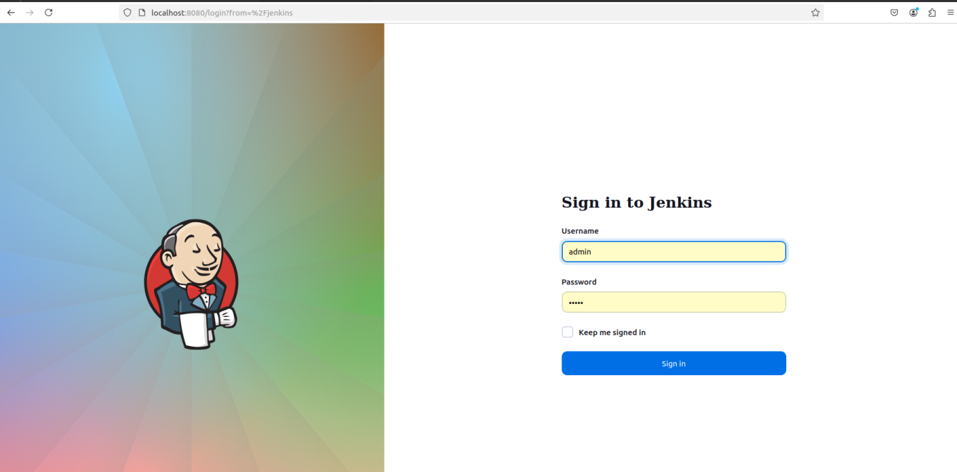

Step 5 : stop the tomcat

./shutdown.sh

1. How to run the Jenkins in 8081 port instead of default port 8080 ?

Step 1 :Open the **server.xml** file in your Tomcat conf directory:

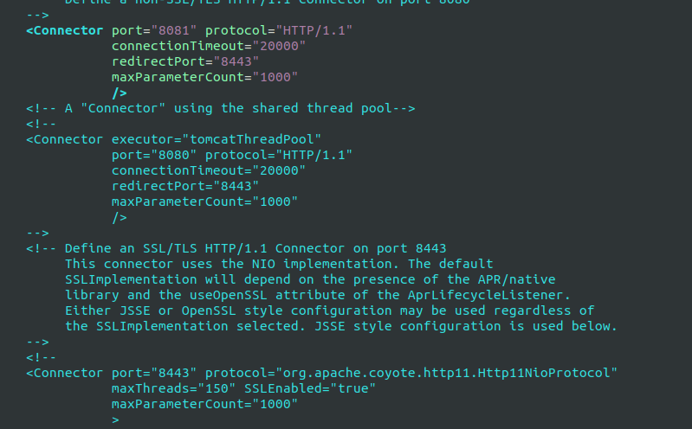

Step 2: Restart tomcat: ./shutdown.sh && ./startup.sh

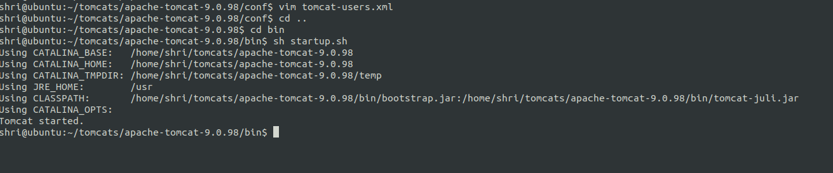

Step 3 :acess<http://localhost:8081/jenkins>

Step 4: stop the tomcat using

Sh shutdown.sh

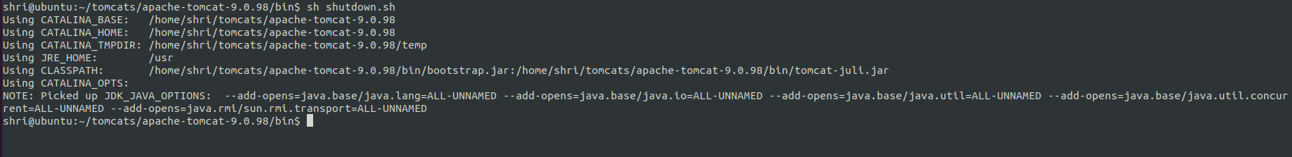

1. Install Jenkins on windows

Download Java with the mentioned version **Java\jdk-17** and install

Step 1: copy the path **C:\Program Files\Java\jdk-17** and paste it in environment variables (system variables) as shown in below picture

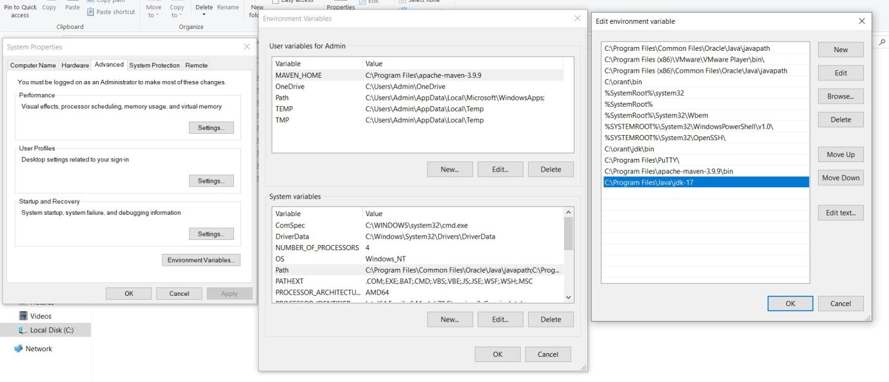

Step 2: Download 2.479.3 LTS for and Install Jenkins

Step 3: select logon type as Run service as localsystem (not recommended)

Step 4: Default Port Number would be 8080 and Test Port and click on next button

Step 5: Mention the path where java directory has installed C:\Program Files\Java\jdk-17

Step 6: Select Firewall exception and select the option (will be installed on local hard drive) and install it.

Step 7: Check in browser by giving localhost:8080

Step 8: It will open and ask for Administrator Password

Step 9: Administrator Password will be in below mentioned path

**C:\ProgramData\Jenkins\.jenkins\secrets** and select initialAdminPassword and open with notepad copy the password and paste in browser.

Step 10: Customize Jenkins with Installed suggested plugins and wait until it finishes.

Step 11: Fill the field and select the option save and continue

Step 12: Instance Configuration is <http://localhost:8080/> and save & finish.

Step 13: Your Jenkins is ready to use.

